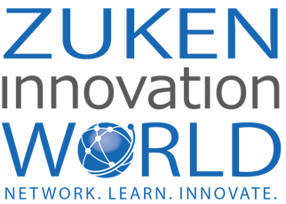

Hi [insert manager’s name],

I’m really interested in attending Zuken Innovation World (ZIW) on June 5-8 in Scottsdale, AZ. (full details are here) and would like to know if you can allocate financial support for me to do so.

Zuken’s event focuses on education and is filled with opportunities for networking and learning. The event is co-located with Vitech’s Integrate23, so there are more than 90 classes across seven dedicated tracks. And a single fee provides entry into both events. Classes cover product training, customer and partner case studies, design best practices, and forward-looking topics.

The Expert Bar will give me an opportunity to meet one-on-one with Zuken technical staff to answer my questions about [X]. I can meet with partners in the Technology Showcase and learn more about their complementary technologies. During the Zuken-360 session, I’ll be able to ask the management team questions about [X].

ZIW is different from a typical user event. It’s more focused on networking opportunities, connecting professionals from multiple industries, and providing practical knowledge to help attendees be more productive in our design environment immediately.

Between the content presented in the 90+ classes and sessions, I plan to strengthen my skills in [X], [Y], [Z], and from the research, I’ve done into the upcoming event, I think it will help me in attaining these goals:

- Goal #1:
- Goal #2:
- Goal #3:

These are some of the classes I’d like to attend:

- Class #1:
- Class #2:
- Class #3:

[For E3.series Users] As an added bonus, Zuken is offering a professional certification exam for E3.series, our wire harness design tool. This certification exam would normally cost $499, but it’s being offered free for ZIW attendees. The exam will validate my foundational-level knowledge in E3.schematic and E3.cable.
I believe ZIW would benefit our investment in Zuken’s tools by furthering my knowledge and expertise as a user. Plus, connecting with other customers and learning about their design challenges can give us insight and inspiration. I’ll submit a post-event report, including an executive summary, major takeaways, tips, and pictures from the event.
I welcome the chance to discuss this opportunity with you in further detail. Let me know what additional information I can provide to help you make your decision.
Thanks for your consideration,
[Your name]

