Zuken News

Ref: Z0541
Date: December 8, 2020

Zuken USA Announces Partnership with Delta Sigma Company
Harness Builder for E³.series and ProjectionWorks offer augmented reality for harness manufacturing

December 8, 2020 – Westford, MA, USA – Zuken USA Inc., and Delta Sigma Company announced a partnership to bring enhanced manufacturing using augmented reality to the wire harness design and manufacturing process. Harness Builder for E³.series, part of Zuken’s popular electrical harness design suite of tools, now has the capability to drive Delta Sigma Company’s ProjectionWorks. This partnership falls under Zuken’s digital engineering initiative, providing a solution consistent with digital engineering practices by eliminating spreadsheets and manual processes.

ProjectionWorks, an award-winning manufacturing automation solution, uses projection-based augmented reality technology to provide step by step visual instructions for harness assembly. By visualizing the cable assembly connection points, routing, and instructions, manufacturing productivity is dramatically improved.

“ProjectionWorks is the latest innovation in augmented reality technology, enabling smart manufacturing processes which save businesses time and money,” said Craig Cappai, president of Delta Sigma Company. “It is really exciting to work with Zuken to bring to market a new production process for wire harness design that has the potential to significantly boost productivity.”

Harness Builder for E3.series utilizes an extensive database of connectors, cables, wires, labels, clips, cable protection, and other harness accessories to design a complete wire harness. Using the seamless interface, detailed design information is passed to ProjectionWorks for the sequencing of tasks to build the physical harness. Wire and cable design data can also be sent directly to state-of-the-art wire cutting and labeling machines for automated processing. Using ProjectionWorks, working notes and part positioning are projected directly onto a formboard to facilitate accurate assembly of the harness. Once the harness has been created digitally, test data can be delivered directly from Harness Builder for E³.series to all major automated harness testing machines.

“As products become more and more complex, leveraging the latest technologies such as augmented reality for manufacturing is key to our success,” said Kent McLeroth, president of Zuken USA Inc. “Partnering with Delta Sigma combines the best in wire harness design and manufacturing that will ultimately boost our mutual customers’ productivity. We will continue to identify and collaborate with exceptional partners like Delta Sigma Company to deliver the latest in design and manufacturing solutions consistent with our digital engineering initiative.”

Harness Builder for E³.series supports the custom wire and cable harness market and is designed specifically for harness manufacturers for the accurate quotation and full creation of nail-board/peg-board documentation. Harness manufacturers can save time while easily creating their harness documentation from drawings or a wirelist. Using Harness Builder for E3.series for digital design, combined with ProjectionWorks for assembly, it is now possible to make fast, accurate harness estimates, design the harness, and manufacture that harness in a highly productive manner.

The ProjectionWorks integration is available today in Harness Builder for E3.series 2020. Learn more by viewing this on-demand webinar: Augmented Reality Meets Harness Manufacturing https://www.zuken.com/us/resource/webinar-augmented-reality-meets-harness-manufacturing/

- Ends -
Text and images are available for download.

Images and Captions
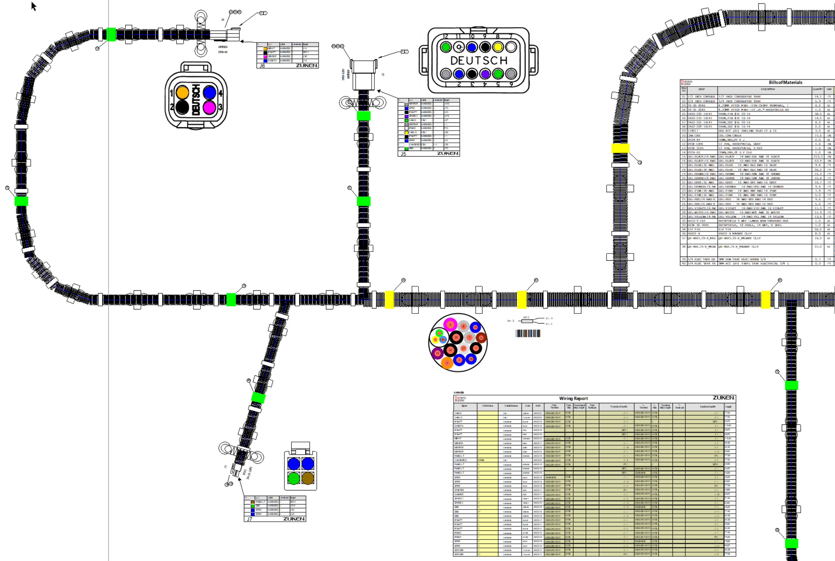
∫Z0541 Delta Sigma_1.png:
Harness Builder for E3.series utilizes an extensive database of connectors, wires, and other harness accessories to design a complete wire harness.

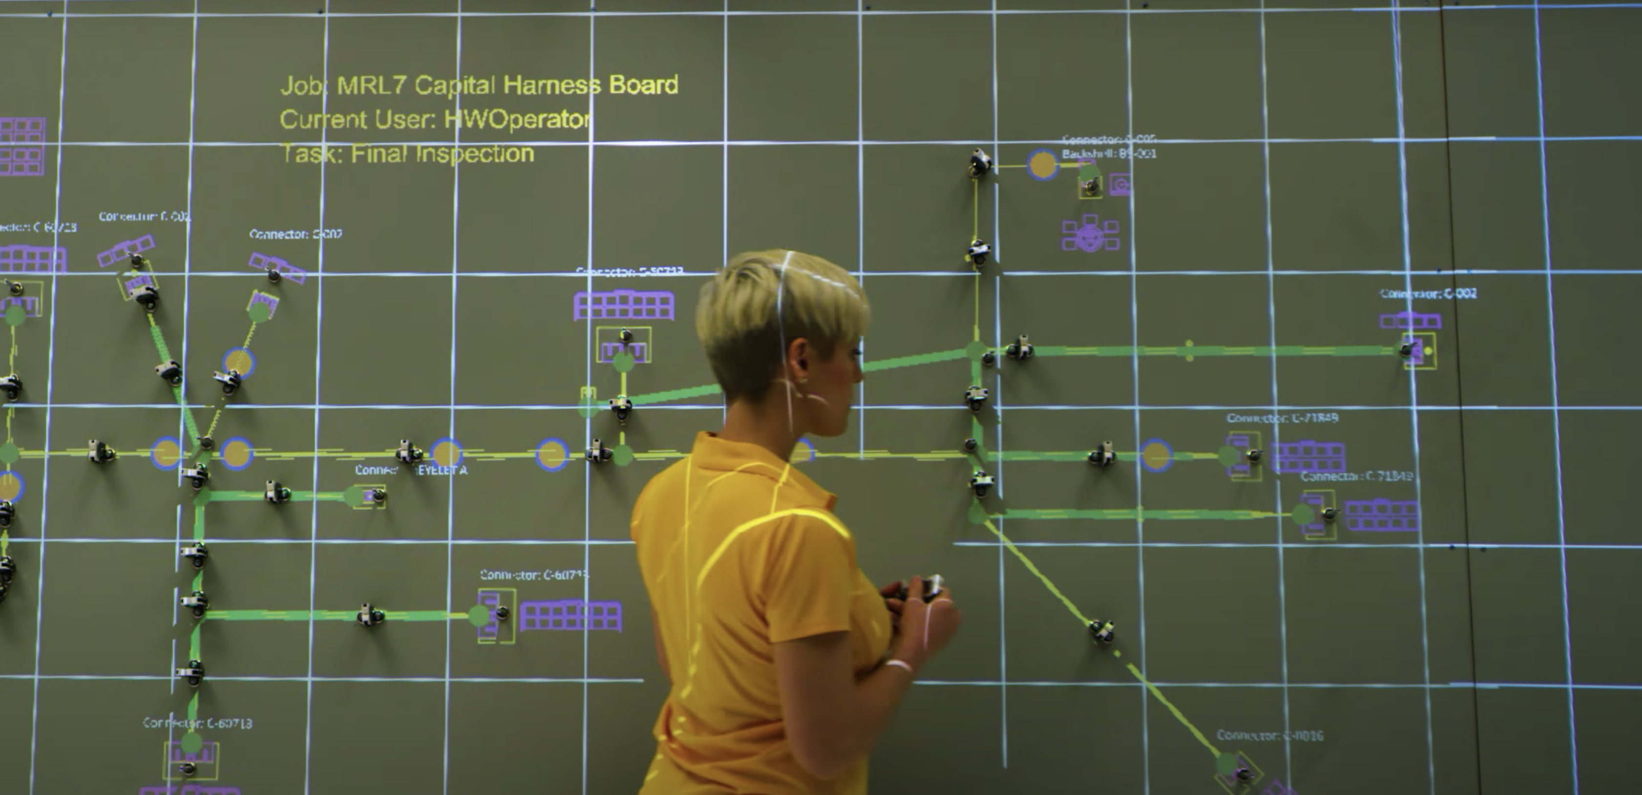
∫Z0541 Delta Sigma_2.png:
Wire harness assembly with projected work instructions

About Zuken
Zuken is a global provider of leading-edge software and consulting services for electrical and electronic design and manufacturing. Founded in 1976, Zuken has the longest track record of technological innovation and financial stability in the electronic design automation (EDA) software industry. The company’s extensive experience, technological expertise and agility, combine to create world-class software solutions. Zuken’s transparent working practices and integrity in all aspects of business produce long-lasting and successful customer partnerships that make Zuken a reliable long-term business partner.
Zuken is focused on being a long-term innovation and growth partner. The security of choosing Zuken is further reinforced by the company’s people—the foundation of Zuken’s success. Coming from a wide range of industry sectors, specializing in many different disciplines and advanced technologies, Zuken’s people relate to and understand each company’s unique requirements. For more information about the company and its products, visit www.zuken.com.

About Delta-Sigma Company
Delta Sigma Company (DSC) specializes in designing and building custom systems used to automate precision manufacturing and complex assembly tasks. Initially focused on custom low observable test equipment, DSC has expanded our capabilities to include engineer-to-order factory automation systems, robotics, and cutting-edge augmented reality systems.

In 2005, we began developing 3D optical projection technologies, which later grew into our patented ProjectionWorks product line in 2009. Delta Sigma now offers a family of augmented reality products designed to project visual work instructions in true size and color directly onto any vehicle, object, or surface, regardless of shape or size. This enables manufacturers to reduce time on task and eliminate errors in manufacturing and complex assembly processes. ProjectionWorks can be applied to assembly, painting, and wire harness and cable assembly.

For more information, contact your local PR representative:

America

Amy Clements, Zuken USA Inc., 238 Littleton RD, STE 100, Westford, MA 01886
Tel: +1 972-691-3284
E-mail: amy.clements@zukenusa.com
Twitter: @ZukenAmericas

Meta keywords
Harness design, harness manufacturing, augmented reality, 3D, optical projection

Web summary
Zuken’s Harness Builder for E3.series now has direct integration to drive Delta Sigma Company’s ProjectionWorks for easy wire harness design and manufacturing.

